AB AWARDS 2015 Nomination Form
Celebrating Youth Achievement in Argyll and Bute
Awards 2015
Nomination Form
Please tick nomination category;
Name of Proposer
Contact Details
Address and Email
Phone Number
Name of Individual or Group
Contact Details
Address and Email
Phone Number
Please note nominees will be invited, if successful, to attend the Celebrating Youth Achievement Awards in the Phoenix Cinema, Oban on Thursday 24th September 2015 along with the person nominating them.
Closing date for nominations – Midnight Friday 17th July 2015
Please send completed form and nomination details to:
Kerry Halliday, Youth Services, Library Headquarters, Highland Avenue, Sandbank, Argyll, PA23 8QZ youthservices@argyll-bute.gov.uk
No
Yes
Are the individual/ group aware of this nomination?
Nomination Details
Sporting Award
Young Arts Award
Health & Wellbeing
Citizenship Award
Youth Environment Award
Young Entrepreneur Award
Young Volunteering Award
Unsung Hero Award
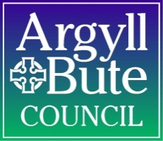
AB AWARDS 2015 Nomination Form
Celebrating Youth Achievement in Argyll and Bute
Awards 2015
Nomination Form

Please use this space to tell us why the person/group deserves to win this award. All entries will be judged on the information supplied so please ensure you give as much detail as possible. (please attach additional sheet if required )
